Python Basics

Day 1 - Programming Languages, Full Stack, SDLC, Problem-solving

- What is a Programming Language?
  - Types of programming language
    - High-level language
    - Low-level language
- What is Full Stack Development?
- Introduction to SDLC (Software Development Life Cycle)
The software development life cycle (SDLC) is a step-by-step process that development teams use to create high-quality, cost-effective and secure software.

Different SDLC models approach these phases in different ways. In some models, such as the waterfall model, the stages are completed sequentially. In others, such as iterative processes like agile, stages can be worked on in parallel. The chosen development model usually depends on organizational needs and priorities and project requirements.

SDLC stages :
- Requirement Gathering and Analysis
  - Understand what the client or stakeholders need.
  - Identify functional and non-functional requirements.
  - Result: Software Requirements Specification (SRS) document.
- Planning
  - Define project scope, timelines, resources, budget, and risk.
  - Choose SDLC model (e.g., Agile, Waterfall).
  - Result: Project plan.
- System Design
  - Design system architecture, database schema, UI/UX, and technology stack.
  - Result: Design Document Specification (DDS), wireframes, etc.
- Implementation / Development
  - Developers write the actual code.
  - Follow best practices, version control, and coding standards.
  - Result: Working software modules.
- Testing
  - QA team tests the system for bugs, performance, and usability.
  - Types: unit testing, integration testing, system testing, UAT.
  - Result: Test reports, bug fixes.

- Deployment
  - Release the product to a live environment (production).
  - Can be done in phases or all at once.
  - Result: Live application available to users.
- Maintenance and Support
  - Fix issues post-deployment, apply updates, and provide support.
  - Ensure system runs smoothly and securely over time.

SDLC benefits :
- Deliver higher-quality software
- Increase productivity
- Minimize risk
- Improve project transparency and visibility
- Promote collaboration
- Efficiently manage costs and resources
- Improve customer satisfaction

Introduction to Waterfall models and Agile

- Quiz
Day 2 - Language processors, Flowchart, Algorithm
- Language Processors
  - Types of language processors
    - Interpreter
    - Compiler
- Introduction to Flowcharts
Flowchart Symbols:
○ Oval: Start and End
○ Parallelogram: Inputs or outputs
○ Rectangle: Actions or Instructions
○ Diamond: Decisions (yes/no paths)
○ Arrows: Direction of flow

- Understanding Algorithms
- Basic Algorithm Example: Create a flowchart and an algorithm to find the largest number out of three numbers:
1. Start
2. Take three numbers as input
3. Compare the first number with the second
4. If the first is greater, compare it with the third
5. Otherwise, compare the second with the third
6. Display the largest number
7. End
- Quiz 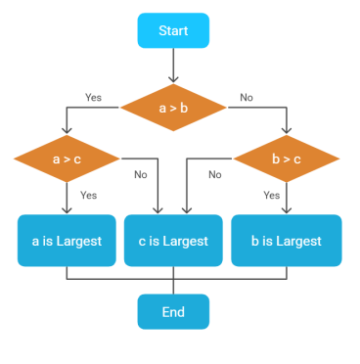

Day 3 - Python Introduction
- Part 1: Introduction to Python
  - 1. Brief History and Origin of Python
  - 2. Overview of Python's Role in the Tech Industry
  - 3. Why Learn Python?

- Part 2: Key Features of Python
  - Simple and Easy-to-Read Syntax
  - Interpreted Language
  - High-Level and Dynamically Typed
  - Extensive Libraries and Community Support
- Part 3: Installation of Python
  - 1. Setting Up Python on Windows/Mac/Linux
  - 2. Using Python IDLE vs. Jupyter Notebook
  - 3. Verifying Installation and Basic Command-Line Usage

- Part 4: Applications of Python
- 1. Common Areas of Application:
- 2. Examples of Popular Python Applications and Frameworks

- Part 5: Basic Syntax and Elements of Python
  - What are variables ?

  - Tokens in Python
In Python (and all programming languages), a token is the smallest unit in the source code that has meaning to the compiler or interpreter.
Types of tokens :
  - Keywords
Reserved words with special meaning
  - Literals
Values assigned
  - Identifiers
Names
  - Rules for Naming Identifiers:
- Must begin with a letter or underscore (_).
- Can contain letters, digits, and underscores but no spaces or special symbols.
- Python is case-sensitive, so Name and name are different.
Best Practice: "Use clear, descriptive names like student_name or total_amount. This makes your code easier to understand."

- Punctuators
Punctuators are characters like (), {}, :, ,, etc. that help define the structure of Python code.They don’t perform calculations — they separate or group elements in the code.

- Quiz
Day 4 – Operators
Operators
Arithmetic Operators
These operators perform mathematical calculations:
- +: Addition
- -: Subtraction
- *: Multiplication
- /: Division
- %: Modulus (remainder of division)
- //: Floor division (division, rounded down to the nearest integer)
- **: Exponentiation (power)
Assignment Operators
These operators assign values to variables:
- =: Assign
- +=: Add and assign
- -=: Subtract and assign
- *=: Multiply and assign
- /=: Divide and assign
- %=: Modulus and assign
- //=: Floor division and assign
- **=: Exponentiation and assign
Comparison Operators
These operators compare values and return boolean results:
- ==: Equal to
- !=: Not equal to
- >: Greater than
- <: Less than
- >=: Greater than or equal to
- <=: Less than or equal to
Logical Operators
These operators combine or modify boolean values:
- and: Returns True if both statements are true
- or: Returns True if at least one statement is true
- not: Returns the opposite of a boolean value
Identity Operators
These operators check if two variables refer to the same object in memory:
- is: Returns True if both variables are the same object
- is not: Returns True if both variables are not the same object
Membership Operators
These operators check if a value is present in a sequence:
- in: Returns True if a value is found in a sequence
- not in: Returns True if a value is not found in a sequence
Bitwise Operators
These operators perform operations on individual bits of integers:
- &: Bitwise AND
- |: Bitwise OR
- Operator Precedence
When multiple operators are used in an expression, Python follows a specific order of precedence:
- Parentheses ()
- Exponentiation **
- Unary plus, minus, and bitwise NOT +x, -x, ~x
- Multiplication, division, modulus, and floor division *, /, %, //
- Addition and subtraction +, -
- Bitwise shift <<, >>
- Bitwise AND &
- Bitwise XOR ^
- Bitwise OR |
- Comparison operators ==, !=, >, <, >=, <=
- Identity operators is, is not
- Membership operators in, not in
- Logical not
- Logical and
- Logical or
- Quiz
Day 5 - Simultaneous assignments, Data Types, Input, Print, Comments, Type casting
- Introduction to Simultaneous Assignment
- Data Types in Python

- Data Structure
Data structures are ways to organize and store data so that it can be used efficiently in a computer program.

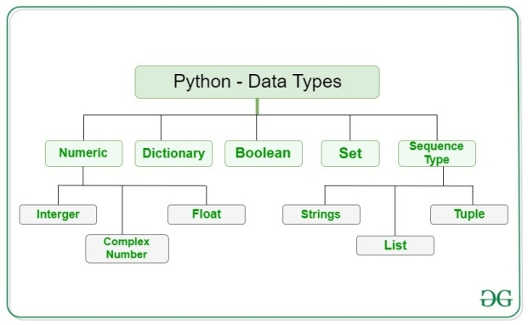
- Mutable and Immutable
- Unpacking
- Input and Output in python
  - Input
  - print
- Comments in python
  - Single line comment
  - Multiline comment
- Type casting
- Quiz
Day 6 - Git Basics

- Introduction to Git
- What is Git?
Git is a distributed version control system that tracks changes in your code and allows multiple people to collaborate efficiently.
- Why should Python developers use Git?
○ Tracks versions of Python scripts and projects.
○ Helps teams work together without overwriting each other's work.
○ Integrates with platforms like GitHub, GitLab, or Bitbucket to store code online.

- Key Git Concepts:
● Repository (Repo): A directory managed by Git.
● Commit: A snapshot of your code at a specific point in time.
● Branch: A parallel version of your code where you can experiment.
● Merge: Combining changes from different branches.
● Remote Repository: A repository hosted online (like on GitHub).
- Setting Up Git (10 minutes)
Installing Git:
Windows: Download from git-scm.com and install.
Linux: sudo apt install git
Ubuntu: brew install git # macOS
- Configuring Git:
After installation, set up your name and email:
git config --global user.name "Your Name"
git config --global user.email "your.email@example.com"
- Verify Installation:
git –version
- Basic git commands
git init
git status
git add filename with extension # Add single file to staging area
git add .
git commit –m “message”
git log

Day 7 - Git Basics

- Branching and Merging
Create a New Branch: git branch new-feature
Switch to the Branch: git checkout new-feature
Make Changes and Commit: git commit -am "Updated feature"
Merge Branches: git checkout main
git merge new-feature
Delete a Branch: git branch -d new-feature

- Collaborating with Remote Repositories
Connecting to GitHub:
● Create a new repository on GitHub (without README or .gitignore).
● Add the remote repository:
git remote add origin https://github.com/yourusername/repository.git
Pushing Changes:
git push -u origin main
Cloning a Repository
git clone https://github.com/yourusername/repository.git
Pulling Updates
git pull origin main
- Git for Python Projects (15 minutes)
Using .gitignore
Create a .gitignore file to exclude unnecessary files:
__pycache__/
*.pyc
venv/
- Collaborative Workflow
1. Fork a repository and create a branch.
2. Make changes and push them.
3. Open a pull request on GitHub.

Day 8 - Control Statements (if, if-else)
- Introduction to Control Statements (5 mins)
1. Purpose of Control Statements:
○ Teacher: "Control statements allow Python to make decisions. They let us create programs that can adapt to different situations and conditions."
2. Overview of Conditional Logic and Decision-Making:
- If , if elif else , Nested if
Day 9 - Looping - For loop, Range
- Purpose of loops
- Types of loops
for
while
- Iterating over Data structures
- range function and its parametres
- Nested loops
- Loops control statements
  - Continue
  - pass
  - break

Day 10 - Looping - While loop
- Introduction to while loop
- Difference between for and while loop
- Working with else in loops

